You are given the head of a **non-empty** linked list representing a non-negative integer without leading zeroes.

Return *the* head *of the linked list after* ***doubling*** *it*.

**Example 1:**

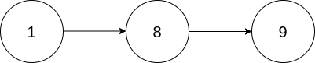

Input: head = [1,8,9]  
Output: [3,7,8]  
Explanation: The figure above corresponds to the given linked list which represents the number 189. Hence, the returned linked list represents the number 189 * 2 = 378.

**Example 2:**

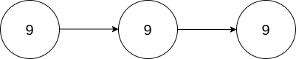

Input: head = [9,9,9]  
Output: [1,9,9,8]  
Explanation: The figure above corresponds to the given linked list which represents the number 999. Hence, the returned linked list reprersents the number 999 * 2 = 1998.

**Constraints:**

* The number of nodes in the list is in the range [1, 104]
* 0 <= Node.val <= 9
* The input is generated such that the list represents a number that does not have leading zeros, except the number 0 itself.